**Project 05：Traffic Lights**

1. **Introduction**

Traffic lights are closely related to people's daily lives, which generally show red, yellow, and green. Everyone should obey the traffic rules, which can avoid many traffic accidents. In this project, we will use Raspberry Pi Pico and some LEDs (red, green and yellow) to simulate the traffic lights.

1. **Components Required**

|  |  |  |  |  |
| --- | --- | --- | --- | --- |
| 17a6d7f241a04d4e932cb06b758197c4 | _DSC2552 | | 红 (4) | y |
| Raspberry Pi Pico\*1 | Raspberry Pi Pico Expansion Board\*1 | | Red LED\*1 | Yellow LED\*1 |
| 绿 (5) |  |  |  |  |
| Green LED\*1 | USB Cable\*1 | 220ΩResistor\*3 | Breadboard\*1 | Jumper Wires |

1. **Circuit Diagram and Wiring Diagram**

# 

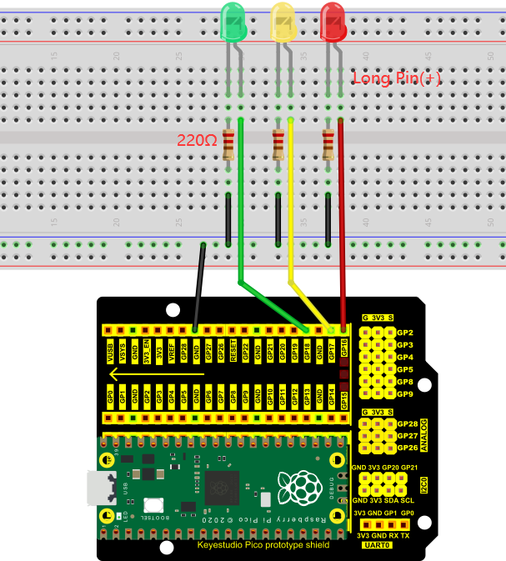

Note:

How to connect an LED

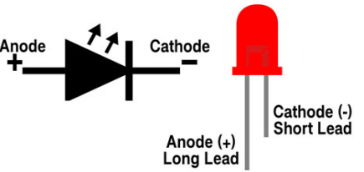

How to identify the 220Ω 5-band resistor

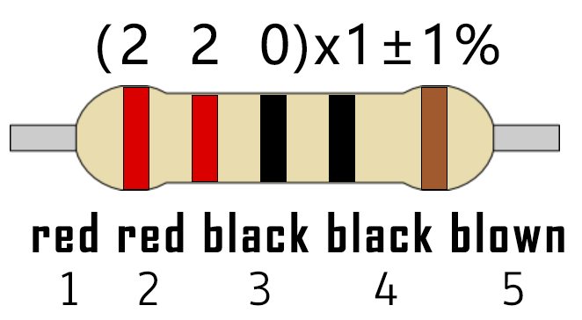

1. **Test Code**

The code used in this project is saved in the file KS3020 Keyestudio Raspberry Pi Pico Learning Kit Ultimate Edition\2. Windows System\1.Python\_Tutorial\2. Python Projects\Project 05：Traffic Lights. You can move the code to anywhere, for example, we can save the code in the Disk(D), the route is D:\2. Python Projects.)

Open“Thonny”, click“This computer”→“D:”→“2. Python Projects”→”Project 05：Traffic Lights”and double left-click the“Project\_05\_Traffic\_Lights.py”.

**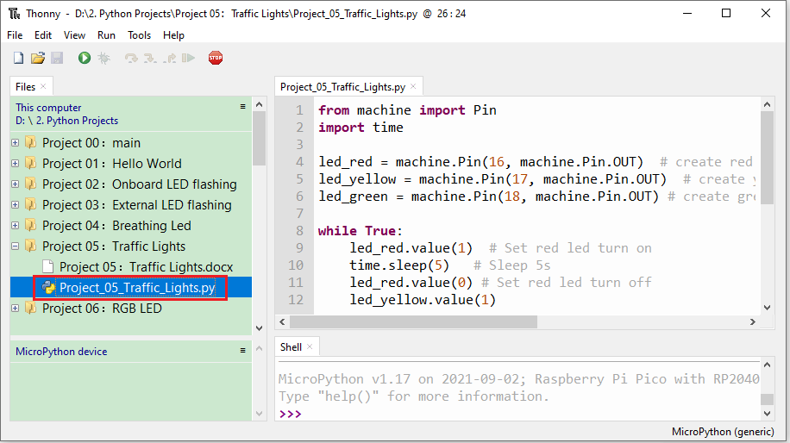**

|  |
| --- |
| from machine import Pin  import time  led\_red = machine.Pin(16, machine.Pin.OUT) # create red led object from Pin 16, Set Pin 16 to output  led\_yellow = machine.Pin(17, machine.Pin.OUT) # create yellow led object from Pin 17, Set Pin 17 to output  led\_green = machine.Pin(18, machine.Pin.OUT) # create green led object from Pin 18, Set Pin 18 to output  while True:  led\_red.value(1) # Set red led turn on  time.sleep(5) # Sleep 5s  led\_red.value(0) # Set red led turn off  led\_yellow.value(1)  time.sleep(0.5)  led\_yellow.value(0)  time.sleep(0.5)  led\_yellow.value(1)  time.sleep(0.5)  led\_yellow.value(0)  time.sleep(0.5)  led\_yellow.value(1)  time.sleep(0.5)  led\_yellow.value(0)  time.sleep(0.5)  led\_green.value(1)  time.sleep(5)  led\_green.value(0) |

1. **Test Result**

Ensure that the Raspberry Pi Pico is connected to the computer, click “Stop/Restart backend”.

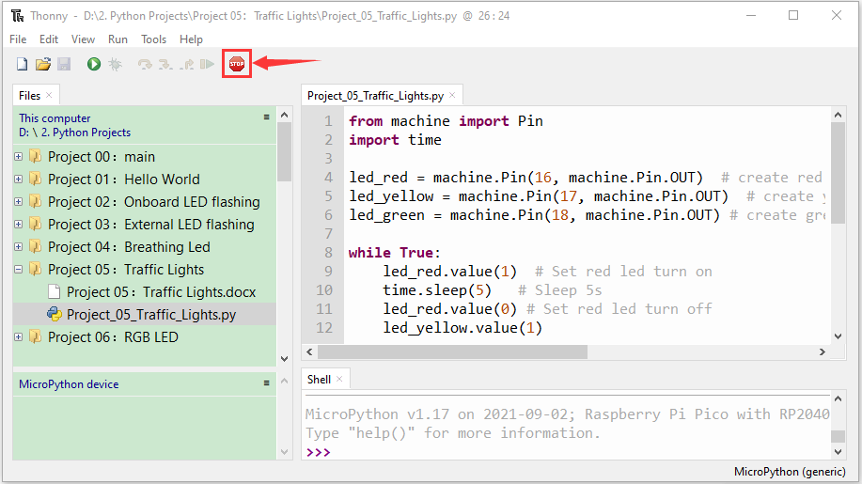

Click“Run current script”, the code starts executing, what we will see are below:

1. First, the green light will be on for 5 seconds and then off;
2. Next, the yellow light blinks three times and then goes off.
3. Then, the red light goes on for five seconds and then goes off.

Repeat steps 1 to 3 above and press“Ctrl+C”or click“Stop/Restart backend” to exit the program.

